
COMSATS University Islamabad
Department of Computer Science

CSC291 Software Engineering
Semester: Spring 2026
BS(AI) – Section 6

Assignment No.2
Group No 15

Title of the Project
ShareWay

Submitted by:
Syed Muhammad Shahzaib Haider Rizvi
FA23-BAI-050

Arhum Fareed
FA23-BAI-006

Muhammad Awais Ali
FA23-BAI-028

Submission Date:
26 – March – 2026

Project Title: ShareWay - Ai Powered Peer to Peer Ride Sharing Platform

1. Project Overview
Scope
ShareWay is a cross-platform mobile application (Android/iOS) built with Flutter that facilitates peer-to-peer ride-sharing among urban commuters. The system leverages Firebase for its real-time backend and OpenStreetMap services for location and routing. It features an intelligent ride-matching algorithm that scores potential rides based on route similarity, time overlap, driver rating, and proximity connecting passengers with the most suitable drivers. The app supports dual user roles (driver and passenger), real-time messaging, live ride tracking, and multiple Pakistani payment methods (Cash, Easypaisa, JazzCash, Bank Transfer).
Problem Statement
In Pakistani urban centers, daily commuters face rising fuel costs, traffic congestion, and limited affordable transport options. Existing ride-hailing services operate on a commercial driver model, making them expensive for routine commutes. There is no widely adopted platform that allows everyday commuters traveling similar routes to share rides, split costs, and reduce traffic leading to underutilized vehicle capacity, higher per-person travel expenses, and increased carbon emissions.
Objectives
- Develop a Peer-to-Peer Ride-Sharing Platform: Create a functional, cross-platform mobile MVP (using Flutter) that allows drivers to offer spare seats and passengers to find matching rides along their route.
- Intelligent Ride Matching: Implement a weighted scoring algorithm that matches passengers with drivers based on route similarity (40%), time overlap (30%), driver rating (20%), and pickup proximity (10%).
- Real-Time Communication & Tracking: Enable in-app messaging between ride participants and live GPS tracking during active rides.
- Trust & Safety: Build a ratings and reviews system that allows both drivers and passengers to rate each other after completed rides, fostering community trust.
- Cost Transparency: Provide estimated fare calculation (15 PKR/km) with support for multiple local payment methods.
- Offline Resilience: Ensure basic app functionality through Firestore's offline persistence when internet connectivity is intermittent.
System Limitations / Constraints
- Geographic Limitation: Location search and geocoding are constrained to Pakistan using OpenStreetMap Nominatim services.
- No Payment Gateway Integration: The app tracks payment method preferences and transaction records but does not process actual digital payments settlement happens outside the app.
- Hardware Dependency: Real-time tracking and map features require a device with GPS capability and adequate processing power.
- Client-Side Matching: The ride matching algorithm runs on the client device rather than a dedicated server, which may not scale efficiently for a very large user base
- Fare Estimation Only: Fares are estimated at a fixed rate (25 PKR/km) and are not legally binding; actual cost is agreed upon between driver and passenger.

2. UML Use Case Diagram:
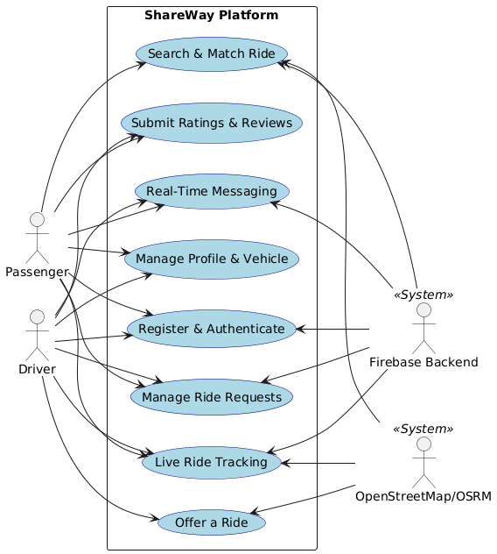

3. Detailed Use Cases:
Use Case 1: Send Real-Time Message
Use Case ID: | UC-4.1
Use Case Name: | Send Real-Time Message
Actors: | Passenger/Driver (Primary), Firebase (Secondary)
Preconditions: | 1. A ride request has been accepted.  2. The system has generated a unique chat room for the ride participants.
Postconditions: | 1. Message is securely delivered and stored in the Firebase Firestore stream.  2. Recipient receives the message in real-time.
Normal Flow: | 1. User opens the active ride details.  2. User taps the "Chat" icon.  3. System retrieves the chat history from Firestore.  4. User types a message and taps "Send".  5. System pushes the text payload to the specific Firestore document stream.  6. System updates the UI to show the sent message.  7. Secondary actor (Firebase) pushes the update to the recipient's device.
Alternative Flows: | None.
Exceptions: | 5a. Network Unavailable:  1. In step 5, if the device is offline, the system caches the message locally using Firestore offline persistence.  2. System displays a "clock" icon next to the message indicating pending delivery.  3. When the network is restored, Use Case resumes at step 5.
Includes: | None.
Quality Requirements: | Message delivery delay should not exceed 1-2 seconds under normal network conditions.

Use Case 2: Submit Rating & Review
Use Case ID: | UC-4.2
Use Case Name: | Submit Rating & Review
Actors: | Passenger/Driver (Primary), Firebase (Secondary)
Preconditions: | 1. A ride has been marked as "Completed" by the Driver.
Postconditions: | 1. The target user's overall average rating is recalculated and updated.  2. The review is visible on the target user's public profile.
Normal Flow: | 1. System prompts the User with a "Rate your ride" screen upon ride completion.  2. User selects a star rating (1 to 5).  3. User inputs an optional text comment.  4. User taps "Submit".  5. System writes the review payload to the target user's database document.  6. System calculates the new average rating for the target user.  7. System displays a "Thank You" confirmation and dismisses the prompt.
Alternative Flows: | 1a. User Skips Rating:  1. In step 1, User taps "Skip for now".  2. System places a persistent notification in the User's dashboard to complete the rating later.  3. Use Case terminates.
Exceptions: | 4a. Database Write Failure:  1. In step 5, if the database write fails, system displays "Submission failed. Try again."  2. Use Case resumes at step 4.
Includes: | None.
Quality Requirements: | Ratings must be strictly tied to completed rides to prevent review manipulation.

Use Case 3: View Filtered Ride History
Use Case ID: | UC-4.3
Use Case Name: | View Filtered Ride History
Actors: | User (Primary)
Preconditions: | 1. User is authenticated and has participated in at least one prior ride.
Postconditions: | 1. User successfully views the persistent log of past rides filtered by their specific criteria.
Normal Flow: | 1. User navigates to the "Ride History" tab.  2. System queries the database for all rides associated with the User's ID.  3. System displays a chronological list of past rides.  4. User selects the "Role Filter" (e.g., "As Driver" or "As Passenger").  5. System applies the filter locally and re-renders the list.  6. User taps a specific ride to view detailed transaction data, past route, and partner profile.
Alternative Flows: | None.
Exceptions: | 2a. No Ride History Found:  1. In step 2, if the user has no past rides, the system displays an empty state graphic.  2. System suggests a call-to-action (e.g., "Find your first ride").  3. Use Case terminates.
Includes: | None.
Quality Requirements: | The history log must utilize pagination or lazy-loading to prevent memory strain if the user has hundreds of past rides.

Use Case 4: Cancel Ride Match
Use Case ID: | UC-4.4
Use Case Name: | Cancel Ride Match
Actors: | Passenger/Driver (Primary), Firebase (Secondary)
Preconditions: | 1. A ride request has been accepted, but the ride has not yet started.
Postconditions: | 1. Ride status is updated to "Cancelled".  2. If Driver canceled, Passenger is notified. If Passenger canceled, Driver's available seats are incremented.
Normal Flow: | 1. User opens the upcoming ride details.  2. User taps "Cancel Ride".  3. System prompts User for a cancellation reason (dropdown menu).  4. User selects a reason and confirms cancellation.  5. System updates the ride status in the database.  6. System re-allocates the seat capacity (if applicable).  7. System triggers a push notification to the other party alerting them of the cancellation.
Alternative Flows: | 2a. Accidental Tap:  1. In step 3, User taps "Nevermind, go back".  2. System dismisses the prompt.  3. Use case terminates.
Exceptions: | 1a. Ride Already Started:  1. In step 2, if the Driver has already triggered "Start Ride", the system rejects standard cancellation and prompts an emergency termination protocol.  2. Use Case terminates.
Includes: | None.
Quality Requirements: | The system must log cancellation reasons for future trust and safety auditing.

